SCIENTIFIC COMPUTING FOR MECHANICAL ENGINEERS FINAL PROJECT
Areeb Khan
1286665

POISSON EQUATION
PROJECT# AP01-2

Abstract:
This final project for MECE 5397-Scientific Computing for Mechanical Engineers is over solving the two-dimensional Poisson equation. Poisson equation can be used to solve many real-life problems. Problems regarding electrostatics, gravity, heat flow and many other situations. It’s important to define four boundary conditions at the four corners to make the solution well defined. In the project assigned there were three Dirichlet boundary conditions and one Neumann condition and the function U (x, y) was bounded over the following limits: 0<x<2$π$, 0<y<2$π$. Each point is connected to four other points located along the cardinal direction. In a 2D grid each point is connected to four other points located along the cardinal direction. A mesh of points was formed and the accuracy of the approximation increased with the quality of the mesh. If the U matrix is diagonally dominant, i.e. the numerically largest values occur on the diagonal and the code provided check for diagonal dominance then the solution will have to converge.
For this project, the Gauss Seidel and successive over relaxation methods were used to obtain the solution. The Gauss Seidel method is an iterative method that references an updated value um+1,j to solve for the next values. On the other hand, SOR method is a refinement to the Gauss Seidel algorithm and this converges faster and requires less number of iterations. The main purpose of this entire project is learning the process of writing a code and solving a Poisson equation using two iterative methods of solution, employing checkpoints and using data visualization to compare the results.

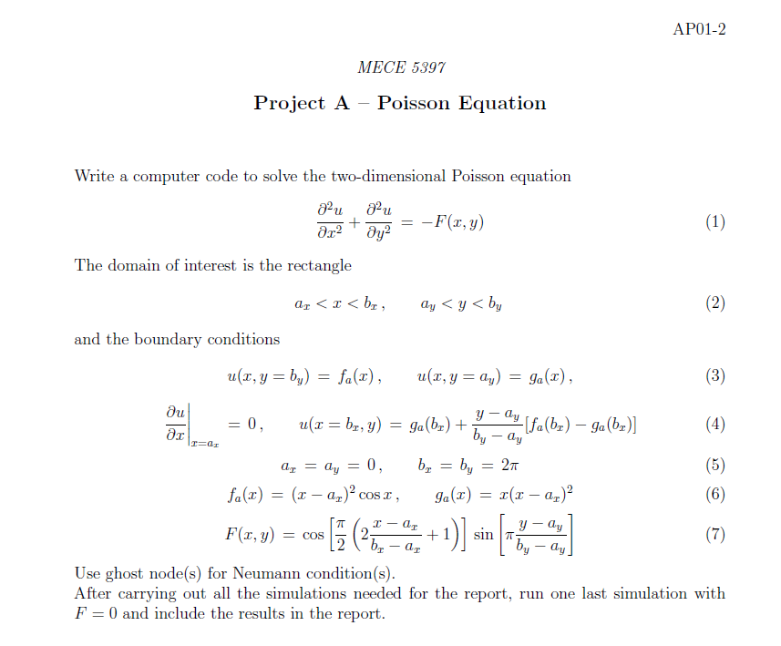

MATHEMATICAL STATEMENT OF THE PROBLEM

$$\frac{∂^{2}U}{∂x^{2}}+\frac{∂^{2}U}{∂y^{2}}=-F\left(x,y\right) (1)$$

DISCRETIZED VERSION OF THE EQUATIONS

$\frac{U_{i-1,j}+U_{i+1,j}-2U_{i,j} }{∆x^{2}}+\frac{U_{i-1,j}+U_{i+1,j}-2U_{i,j} }{∆y^{2}}=F_{i,j}$ (2)
Some of the working done is shown below in the scanned pictures:
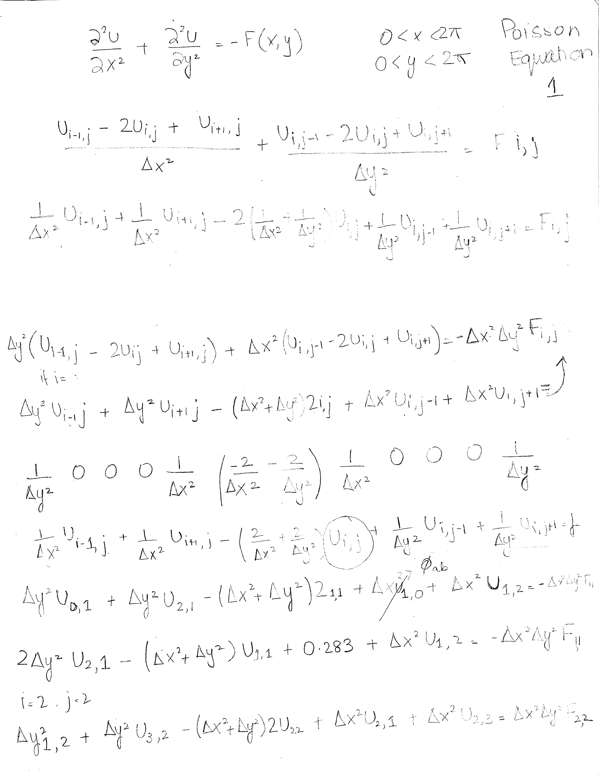

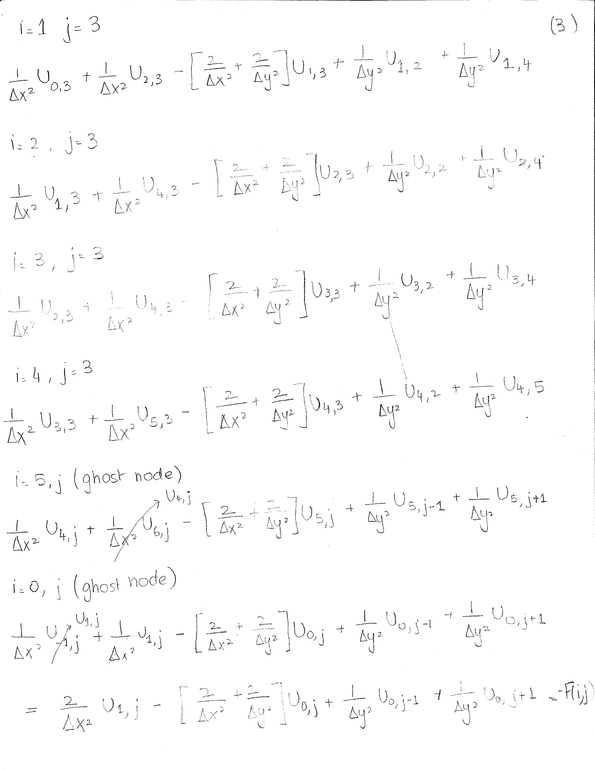

DESCRIPTION OF THE NUMERICAL METHOD
Two iterative solvers were used to solve the Poisson equation on Cartesian grids in two dimensions. The equation is discretized with the equation shown below.
${U^{n+1}}_{i,j}=\frac{{F_{i,j}\left(∆x^{2}∆y^{2}\right)-(U^{n}}_{i-1,j}+{U^{n}}_{i+1,j})∆y^{2}{{ - (U}^{n}}_{i,j-1}+{U^{n}}_{i,j+1}) ∆x^{2} }{-2(∆x^{2}+∆y^{2})}$ (3)
Gauss-Seidel method can be used to make the solution converge faster. This method uses an already computed value to compute the next value as shown in equation 4.

${U^{n+1}}_{i,j}=\frac{{F_{i,j}\left(∆x^{2}∆y^{2}\right)-(U^{n+1}}_{i-1,j}+{U^{n}}_{i+1,j})∆y^{2}{{ - (U}^{n+1}}_{i,j-1}+{U^{n}}_{i,j+1}) ∆x^{2} }{-2(∆x^{2}+∆y^{2})}$ (4)

RESULTS:

Shown Below are the graphs that are obtained with using different sizes of the MxN matrices using both the Gauss-Seidel method and the SOR method

GAUSS-SEIDAL METHOD (25x25)

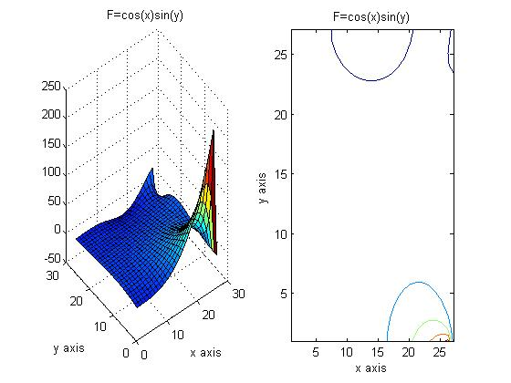

GAUSS-SEIDAL METHOD (75x75)
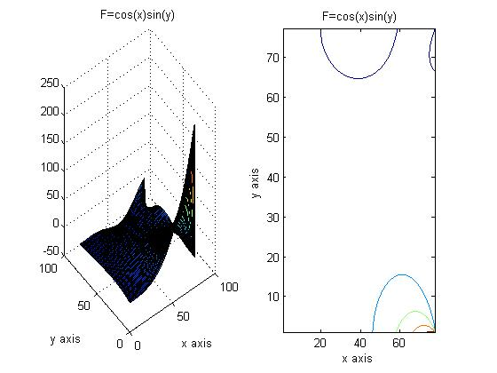

SOR METHOD (25x25)

SOR METHOD (75x75)

Results shown in tabular form below:
 |  | Gauss Seidel | SOR (1.5) | Gauss Seidel | SOR (1.5)
 | M,N | 25x25 | 25x25 | 75x75 | 75x75
F=function | Number of Iterations | 2561 | 941 | 20687 | 7392
F=function | Amount of Time | 0.3792 | 0.1721 | 146.3787 | 9.534

CONCLUSION
Looking at the results we can see that the SOR method is a much better way to go since the number of iterations is lower as well as the time taken for the code to run is lower too. The time taken for a 75x75 using the Gauss Seidel method was very high for me as expected. The reason being the code was run on a laptop that was slow while taking the result values. The same code when ran on a library computer the amount of time was comparatively shorter. The reason why SOR has less time, is because using the SOR method convergence is done much faster.

